**SQL SET OPERATORS**

**Types**

* Union
* Union all
* Intersect
* Minus

**Table 1:**

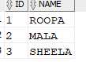

**Table 2:**

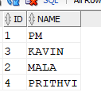

## UNION

When multiple SELECT queries are joined using UNION operator, Oracle displays the combined result from all the compounded SELECT queries,after removing all duplicates and in sorted order (ascending by default), without ignoring the NULL values.

**EXAMPLE**

SELECT * FROM First

UNION

SELECT * FROM Second;

**OUTPUT:**

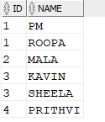

## UNION ALL

UNION and UNION ALL are similar in their functioning with a slight difference. But UNION ALL gives the result set without removing duplication and sorting the data.

**EXAMPLE**

SELECT * FROM First

UNION ALL

SELECT * FROM Second;

**OUTPUT:**

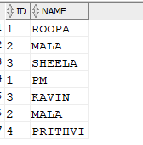

## INTERSECT

Using INTERSECT operator, Oracle displays the common rows from both the SELECT statements, with no duplicates and data arranged in sorted order.

**EXAMPLE**

SELECT * FROM First

INTERSECT

SELECT * FROM Second;

**OUTPUT:**



## MINUS

The Minus operation combines results of two SELECT statements and return only those in the final result, which belongs to the first set of the result.

**EXAMPLE**

SELECT * FROM First

MINUS

SELECT * FROM Second;

**OUTPUT:**

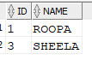

**PICTORICAL REPRESENTATION OF SET OPERATORS**

